

AGENDA
April 27, 2025
Padre Pio Fraternity

Please check the chart for your group assignment when you arrive at the gathering.

Opening Prayer from the Ritual

Minister: In the name of the Father and of the Son and of the Holy Spirit.
All: Amen.
Minister: Most high, all-powerful, good God, praise, glory, and honor and all blessings are yours.
All: Praise and bless my Lord, and give Him thanks, and serve him with great humility.
Minister: Let us pray. (Pause)
Most high, glorious God,
enlighten the darkness of our hearts
and give us right faith, firm hope, and perfect charity,
with wisdom and insight, O Lord,
that we may accomplish your holy and true will. All: Amen
Welcome guests

Ongoing Formation

Theresa Flynn, OFS, will present on St. Francis of Assisi’s “Canticle of the Sun.”
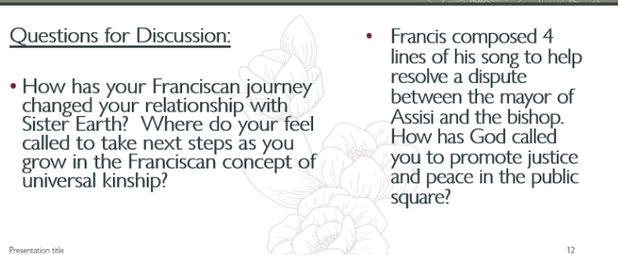
Fellowship and Celebration of April Birthdays

13 Shannon Brooks, OFS; 19 Richard Hammer, OFS; 20 Jeanette Cottone, OFS; 29 Marianne Norris, OFS

Profession anniversary: Gail Halada, April 5, 2004

Business

Treasurer’s Report: Janette Perez, OFS

Formation Director’s Report: Gladys Whitehouse, OFS

Oak City Cares: Mary Cockrill, OFS

Visiting our brothers and sisters: Jeanne Cascieri, OFS

JPIC: Theresa Flynn, OFS

YouFra and Fraternity Directory: Anne Evangelista, OFS

Other business?

Liturgy of the Hours next page

Liturgy of the Hours Evening Prayer 2

Evening Prayer: (Taken from Give Us This Day: Liturgical Press)

Presider: God, come to my assistance.
All: Lord, make haste to help me.

Presider: Glory to the Father . . .
All: As it was in the beginning, is now and will be for ever. Amen
Hymn: Canticle of the Sun

Refrain: The heavens are telling the glory of God,
and all creation is shouting for joy.
Come dance in the forest, come, play in the field,
and sing, sing to the glory of the Lord.

Vs 1. Praise to the sun, the bringer of day,
He carries the light of the Lord in his rays;
The moon and the stars who light up the way
Unto your throne.

Refrain:​ The heavens are telling the glory of God,
and all creation is shouting for joy.
Come dance in the forest, come, play in the field,
and sing, sing to the glory of the Lord.

Vs 2. Praise for the earth who makes life to grow,
The creatures you made to let your life show;
The flowers and trees that help us to know
The heart of love.

Refrain: The heavens are telling the glory of God,
and all creation is shouting for joy.
Come dance in the forest, come, play in the field,
and sing, sing to the glory of the Lord.

Psalm 24:1-6
Side 1: The Lord’s is the earth and its fullness,
the world, and those who dwell in it.
It is the Lord who set it on the seas,
and made it firm on the rivers.
Side 2: Who shall climb the mountain of the Lord?
Who shall stand in God’s holy place?
The clean of hands and pure of heart,
whose souls are not set on vain things,
who have not sworn deceitful words.
Side 1: Blessings from the Lord shall they receive,
and right reward from the God who saves them.
Such are the people who seek the Lord,
who seek the face of the God of Jacob.
Side 2: Glory to the Father . . .
All: As it was in the beginning, is now and will be for ever. Amen
Reader: Scripture 1 Corinthians 15:20-24
Now Christ has been raised from the dead, the first fruits of those who have fallen asleep. For since death came through a human being, the resurrection of the dead came also through a human being. For just as in Adam all die, so too in Christ shall all be brought to life, but each one in proper order: Christ the firstfruits; then, at his coming, those who belong to Christ; then comes the end, when he hands over the kingdom to his God and Father, when he has destroyed every sovereignty and every authority and power.
Sacred Silence
Antiphon
Presider: Do not be unbelieving, but believe.

Canticle of Mary (Magnificat) Luke 1:46-55

All: My soul proclaims the greatness of the Lord,
my spirit rejoices in God my Savior
for he has looked with favor on his lowly servant.

From this day all generations will call me blessed:
the Almighty has done great things for me,
and holy is his Name.

He has mercy on those who fear him
in every generation.

He has shown the strength of his arm,
he has scattered the proud in their conceit.

He has cast down the mighty from their thrones,
and has lifted up the lowly.

He has filled the hungry with good things,
and the rich he has sent away empty.

He has come to the help of his servant Israel
for he has remembered his promise of mercy,
the promise he made to our fathers,
to Abraham and his children for ever.

Glory to the Father, and to the Son,
and to the Holy Spirit,
as it was in the beginning, is now,
and will be for ever. Amen.

Intercessions
Presider: Living God, you know us, and you love us. In hope we pray:
R. God, in your mercy, give us life and hear our prayer.

Presider: Instill Gospel wisdom, honesty, and courage in lawyers, juries, and judges. R.

Presider: May we give praise and always be grateful for the beauty of all of your creation. R.
Presider: Welcome into your everlasting light all who have died in the hope of resurrection, especially Pope Francis. R.

Presider: For what and for whom else shall we pray? R.
Presider: Our Father . . .
All: May God remove our blindness and renew our vision in the light of life in Christ, crucified and risen. Amen.

Closing blessing

Dates to Remember

April 27: Gathering

May 3: North Carolina Museum of Art visit at 10 a.m.
May 24: Oak City Cares

May 31: Candidates will be permanently professed at 11 a.m. Mass, followed by a reception.

We will not have a gathering in May.
Aug. 8-19: Annual Regional Gathering, Black Mountain, NC
Sept. 13: Padre Pio Picnic from 11 a.m.-2 p.m., Bond Park, Cary
Gatherings: June 22, July 27, Aug. 24, Sept. 28 (visitation); Oct. 26; Nov. 16.
Oak City Cares: June 28, July 26, Aug. 23, Sept. 27, Oct. 25, Nov. 23, Dec. 27

