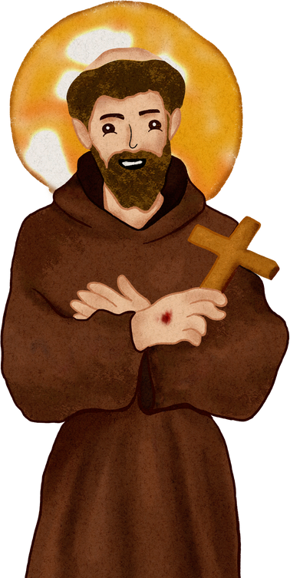

August 24, 2025
Padre Pio
Gathering Agenda

Opening Prayer from the Ritual

Minister: In the name of the Father and of the Son and of the Holy Spirit.
All: Amen.
Minister: Most high, all-powerful, good God, praise, glory, and honor and all blessings are yours.
All: Praise and bless my Lord, and give Him thanks, and serve him with great humility.
Minister: Let us pray. (Pause)
Most high, glorious God,
enlighten the darkness of our hearts
and give us right faith, firm hope, and perfect charity,
with wisdom and insight, O Lord,
that we may accomplish your holy and true will. All: Amen
Welcome guests

Welcome Ritual for our new aspirants:
Jackie Centamore, Carla Forestiere, Christine Skall, Michele Hicks, Vicki Jack, Beth Lyon, Lynn Meserole, Denise Mickalites, Monica Monahan, Rula Osta, Hui Sharp, Michael Sharp, Doug Thoren, Dale Zagiba, and Lori Zagiba

Ceremony of Welcoming Ritual
Commissioning of Sponsors for new aspirants

Ongoing Formation: Travis Bongiorno
Fiat Voluntas Tua (Thy Will Be Done): A
Franciscan Journey in the Love of Mary, the
Mother of God

Discussion questions:
1. How does a relationship with Mary factor into your spiritual life as a Catholic? How does it shape your Franciscan spirituality?

2. What resonated with me in what others here have shared?
Fellowship and Celebrations for August
Birthdays: Henry Simms, OFS, Aug. 10; Valorie Davis, OFS, Aug. 31
Profession Anniversary: John Halada, OFS, Aug. 28

Business

Treasurer’s Report: Janette Perez, OFS.

Oak City Cares: Mary Cockrill, OFS

JPIC: A novena for migrants is scheduled. Please see Marie Bianca for details.

Maureen Copan: Sr. Helen Prejean, author of Dead Man Walking and anti-death penalty activist, will speak to an audience live on Zoom from 7-8 p.m. on Wednesday, Sept. 17, at St. Francis of Assisi Church. Bring your questions because there will be time for a Q&A. Please RSVP to director@catholicsforabolitionc.org

Other business
- YouFra at Immaculate Conception Church, Durham, needs professed members to serve as liaisons with their Franciscan young adult group.
- Congratulations to Ellen Ferrone (minister), Lee Cunningham, and Travis Bongiorno (councilors) who were elected to three-year terms at the Brothers and Sisters of St. Francis Region Council at the Annual Regional Gathering earlier this month. Our gratitude to Zubair Simonson who completed a term as treasurer for the region.

Liturgy of the Hours

Closing blessing
Dates to Remember
St. Michael’s Lent Observance: Now-Sept. 29: All sessions will begin at 7:30 pm and last approximately 30 minutes.
August 31st: **No zoom in observance of Labor Day Weekend. We will pray privately that weekend**
September 7th: 7:30 pm
September 14th: 7:30 pm
September 17: 7 p.m.
September 21st: 7:30 pm
September 28th: **St. Michael's Lent concludes the week of the Feast of the Holy Archangels, September 29th**
These zooms will last approximately 30 mins to an hour.
Zoom link: https://us06web.zoom.us/j/6922596590?omn=88454375099

Padre Pio Picnic Saturday, Sept. 13 from 11 a.m.-2 p.m., Bond Park, Cary. Bring a dish to share and your own nonalcoholic drink. Buehler Picnic Area.(map with location marked)

Gatherings: Sept. 28 (visitation); Oct. 26; Nov. 23. (No meeting in December. Retreat on Dec. 6.)

Oak City Cares: Sept. 27, Oct. 25, Nov. 22, Dec. 27

Book Club: In the Gaps by Brian Kaussner: 7 p.m. Tuesdays, Sept. 16; Oct. 14, and Nov. 18 on Zoom.

Death Penalty: Sr. Helen Prejean, author of Dead Man Walking and anti-death penalty activist, will speak to an audience live on Zoom from 7-8 p.m. on Wednesday, Sept. 17, at St. Francis of Assisi Church. Bring your questions because there will be time for a Q&A. Please RSVP to director@catholicsforabolitionc.org

Immigration Novena: 7 p.m. on Zoom Sept. 21-29. Sponsored by the JPIC Committee. Contact Marie Bianca for more information.

Transitus: 7 p.m. Friday, Oct. 3. Hosted by the friars at Immaculate Conception Church, Durham. We will provide refreshments and assist in any way we can.

Advent daylong retreat: Saturday, Dec. 6. Fr. Tim Kulbicki, OFM Conv., pastor of the UNC-Chapel Hill Newman Center. The topic is the Incarnation.

