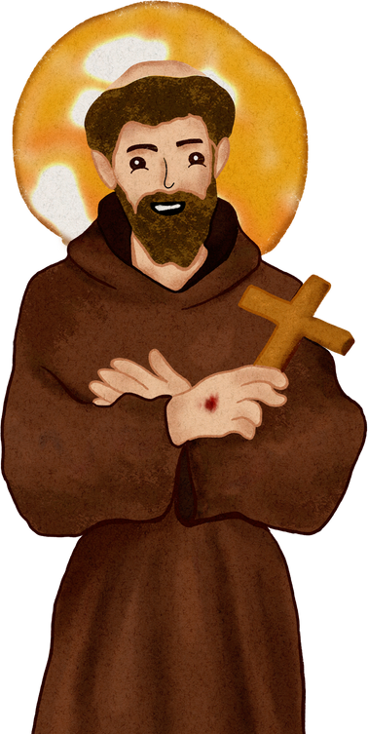

October 26, 2025
Padre Pio
Gathering Agenda

Opening Prayer from the Ritual

Minister: In the name of the Father and of the Son and of the Holy Spirit.
All: Amen.
Minister: Most high, all-powerful, good God, praise, glory, and honor and all blessings are yours.
All: Praise and bless my Lord, and give Him thanks, and serve him with great humility.
Minister: Let us pray. (Pause)
Most high, glorious God,
enlighten the darkness of our hearts
and give us right faith, firm hope, and perfect charity,
with wisdom and insight, O Lord,
that we may accomplish your holy and true will. All: Amen
Welcome guests

Franciscan Wake Service for Gail Halada, OFS

Link to Wake Service

Ongoing Formation: Marianne Norris, OFS
Turning Our Minds and Hearts to God

Discussion questions for Turning Our Minds and Hearts to God
- Round 1: Share a Gospel or a Francis story that had a great impact on your life? How did it change you and lead you on the path of conversion?
- Round 2: What resonated with you as you listened to what was shared?
- Round 3: Is there something you are being called to as a result of this presentation on Article 7 and what you heard shared?
Fellowship and Celebrations
for October Birthdays and Profession Anniversaries
Birthdays: Dorothy Ann Pribbish, October 16; Phil Rzewnicki, October 18; and Courtney Cantrell, October 26.

Profession Anniversaries:
Ida Irwin, October 9, 1955
Marie Bianca, October 13, 1984
Jeannette Cottone, October 20, 2004

Business

Treasurer’s Report: Janette Perez, OFS.

Oak City Cares: Marianne Norris, OFS

Update on Nov.1 trip to Franciscan Center: Ellen Ferrone, OFS

Dec. 6 Retreat: Gladys Whitehouse, OFS & Monica Monahan

Brown Bag Apostolate report: Monica

JPIC: Theresa Flynne, OFS

Reports from Pillar Committees (If committees desire)

Closing Prayer

Almighty, eternal, just and merciful God,
Grant to us miserable ones the grace to do for you
what we know you want us to do.
Give us always to desire what pleases you.
Inwardly cleansed, interiorly illumined
and enflamed with the fire of the Holy Spirit,
may we be able to follow in the footprints
of your beloved Son, our Lord Jesus Christ,
and attain to you, Most High, by your grace alone,
who is perfect Trinity and simple Unity
lives and reigns and is glorified as God almighty
forever and ever. Amen.

Closing blessing

Important Dates

Trip to Franciscan Center, Greensboro: 8 a.m. -4 p.m. Saturday, Nov. 1. (Carpools will leave St. Francis of Assisi parking lot at 8 a.m.) Fr. Louis Canino, OFM, has offered coupons to those who spend $50 or more at the Franciscan store. The trip will include Mass and lunch.

Gatherings: Nov. 23. (No meeting in December.)

Padre Pio Retreat: Beginning with Mass in the Chapel at St. Francis of Assisi at 9:30 p.m. and ending at 3 p.m. Retreat leader is Fr. Tim Kulbicki, OFM, Conv., pastor of the UNC-Chapel Hill Newman Center. The topic is the Incarnation. The day will include morning coffee, snacks, and lunch. Cost is $20. Pay at the retreat. Sign up so we know how many for whom to prepare. https://www.signupgenius.com/go/10C054BA4AC23A0F85-59939906-advent

Oak City Cares: Nov. 22, Dec. 27

Book Club: In the Gaps by Brian Kaussner: 7 p.m. Tuesday, Nov. 18, on Zoom.

2026 Epiphany Party: TBA

2026 Retreat at St. Francis Springs– May 8-10. Registration begins in January.

2026 gathering dates: Jan. 25, Feb. 22, March 22, April 26, May 17, June 28, July 26, Aug. 23, Sept. 27, Oct. 25, Nov. 22.

